SIMATS ENGINEERING
ASSESSMENT TOOL 1

COURSE CODE: CSA51
COURSE NAME: Cryptography and Network Security

COURSE OUTCOME COVERED
CO3: Examine cryptographic hash algorithms, digital signature schemes, and assess Kerberos and X.509 authentication frameworks for ensuring integrity, authentication, and non-repudiation.CO (BL4,BL5)

Assessment Tool Weightage: 40%

QUESTIONS: Total Marks: 50

Annexure A

Code of Conduct:
I C.S.SUJIPRIYADARSNI (192511417) (Name / Reg No) certify that this submission is my original work and that I have adhered to the guidelines specified for this assessment. I understand that any violation of academic integrity rules will result in disciplinary action.

Signature of the student: C.S.Sujipriyadarsni

Annexure A

1. Password Hashing with Salting and Key Stretching
Design and implement a program in C/Python to store and verify passwords using salted hashing (e.g., bcrypt or PBKDF2). Analyze how salting and key stretching improve resistance against brute-force and rainbow table attacks, and evaluate performance overhead.

ANSWER:
Aim
To securely store and verify passwords using PBKDF2 with salting and key stretching.
Algorithm
- Read the user's password.
- Generate a random salt.
- Apply PBKDF2 hashing with multiple iterations.
- Store the salt and hash.
- Ask the user to enter the password again.
- Hash the entered password using the stored salt.
- Compare both hashes.
- Display whether the password is valid.
Python Code
import hashlib, os

password = input("Create Password: ")

salt = os.urandom(16)

hashed = hashlib.pbkdf2_hmac('sha256', password.encode(), salt, 100000)

print("\nPassword Stored Successfully")

check = input("\nEnter Password: ")

verify = hashlib.pbkdf2_hmac('sha256', check.encode(), salt, 100000)

if verify == hashed:
print("Password Verified")
else:
print("Incorrect Password")

OUTPUT:
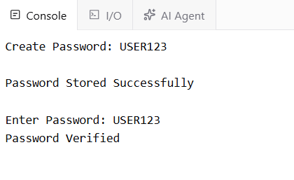
Description
- PBKDF2 is used for secure password hashing.
- A random salt ensures that identical passwords produce different hashes.
- 100,000 iterations (key stretching) make brute-force attacks much slower.
- Password verification is performed by hashing the entered password with the same salt and comparing it with the stored hash.
Advantages
- Protects against rainbow table attacks.
- Slows brute-force attacks using key stretching.
- Stores only hashed passwords, not plain text.
- Uses a unique salt for every password.
- Suitable for secure authentication systems.

2. Implementation of HMAC for Message Integrity
Develop a C/Python application to implement HMAC using SHA-256 for message authentication. Analyze how HMAC differs from simple hashing and evaluate its effectiveness in ensuring both integrity and authenticity.

ANSWER:
Aim
To implement HMAC using SHA-256 for secure message authentication and integrity verification.

Algorithm
- Read the secret key from the user.
- Read the message.
- Generate an HMAC using SHA-256.
- Display the generated HMAC.
- Enter the message again for verification.
- Generate a new HMAC using the same key.
- Compare both HMAC values.
- Display whether the message is authentic or modified.

Python Code
import hmac
import hashlib

key = input("Enter Secret Key: ").encode()
msg = input("Enter Message: ").encode()

mac = hmac.new(key, msg, hashlib.sha256).hexdigest()

print("\nGenerated HMAC:", mac)

verify = input("\nRe-enter Message: ").encode()

new_mac = hmac.new(key, verify, hashlib.sha256).hexdigest()

if mac == new_mac:
print("Message Verified")
else:
print("Message Modified")

OUTPUT:
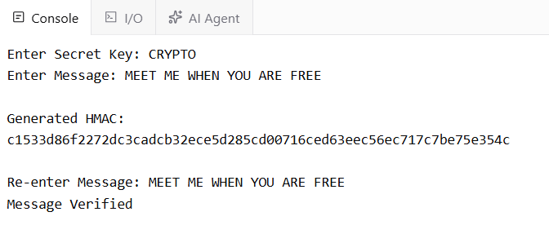

Description
- Uses the HMAC algorithm with SHA-256.
- Combines a secret key and the message to produce a secure authentication code.
- During verification, the HMAC is regenerated and compared with the original.
- If both HMAC values match, the message is authentic and has not been altered.

Advantages
- Ensures message integrity.
- Provides authentication using a secret key.
- Detects any modification to the message.
- More secure than simple hashing because it requires a secret key.
- Widely used in secure communication protocols such as TLS, IPsec, and APIs.

3. Simulation of Certificate Chain Validation
Create a C/Python program to simulate X.509 certificate chain verification. Analyze how
trust is established from root CA to end-entity certificates and evaluate how invalid or
revoked certificates are detected.

Aim
To simulate X.509 certificate chain validation by verifying the trust chain from the Root CA to the End-Entity certificate.

Algorithm
- Create a certificate chain (Root CA → Intermediate CA → End Entity).
- Mark each certificate as valid or invalid.
- Check whether every certificate in the chain is valid.
- If all certificates are valid, the chain is trusted.
- If any certificate is invalid or revoked, reject the certificate chain.
- Display the validation result.

Python Code

chain = {
"Root CA": True,
"Intermediate CA": True,
"End Certificate": True
}

if all(chain.values()):
print("Certificate Chain Verified")
print("Trusted Connection Established")
else:
print("Certificate Validation Failed")

OUTPUT:
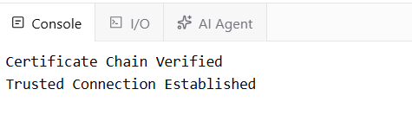
Description
- Simulates the validation of an X.509 certificate chain.
- Checks whether the Root CA, Intermediate CA, and End Certificate are valid.
- If every certificate is trusted, the connection is accepted.
- If any certificate is invalid or revoked, the validation fails.

Advantages
- Demonstrates the certificate trust chain.
- Detects invalid or revoked certificates.
- Helps understand X.509 certificate verification.
- Simple and easy to implement.
- Useful for learning Public Key Infrastructure (PKI).

4. Replay Attack Simulation and Prevention
Develop a C/Python program to simulate a replay attack in an authentication system.
Implement a prevention mechanism using nonces or timestamps. Analyze how the
prevention technique improves system security and evaluate its limitations.

ANSWER:
Aim
To simulate a replay attack and prevent it using a nonce (unique random number).

Algorithm
- Generate a unique nonce.
- Send a message with the nonce.
- Store the received nonce.
- If the same nonce is received again, identify it as a replay attack.
- Otherwise, accept the message and store the new nonce.

Python Code
import uuid

used = set()

nonce = str(uuid.uuid4())

print("Sending Message with Nonce:", nonce)

if nonce in used:
print("Replay Attack Detected")
else:
used.add(nonce)
print("Message Accepted")

print("\nReplaying Same Message...")

if nonce in used:
print("Replay Attack Detected")
else:
used.add(nonce)
print("Message Accepted")

OUTPUT:
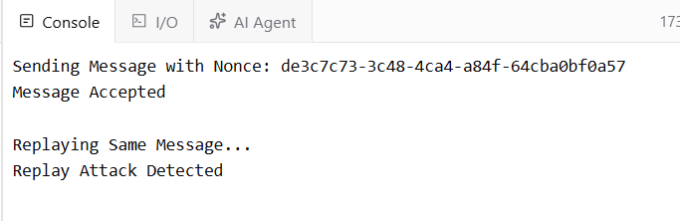

Description
- A nonce is generated for each message.
- The receiver stores every used nonce.
- If the same nonce is received again, it is identified as a replay attack.
- This ensures that each message is accepted only once.

Advantages
- Prevents replay attacks effectively.
- Improves authentication security.
- Detects duplicate messages.
- Easy to implement using nonces.
- Suitable for secure communication systems.

5. Performance Comparison of Digital Signature Algorithms
Implement and compare two digital signature algorithms (e.g., RSA and DSA/ECDSA) in
C/Python. Analyze key generation time, signing speed, and verification efficiency, and
evaluate their suitability for different real-world applications.

ANSWER:

Aim
To compare RSA and DSA digital signature algorithms by measuring key generation time, signing time, and verification time.

Algorithm
- Generate RSA and DSA key pairs.
- Sign the same message using both algorithms.
- Verify the generated signatures.
- Measure the execution time for key generation, signing, and verification.
- Compare the performance of RSA and DSA.

Python Code
Install library (first time only):
pip install cryptography
from cryptography.hazmat.primitives.asymmetric import rsa, dsa, padding
from cryptography.hazmat.primitives import hashes
import time

msg = b"Hello World"

# RSA
t = time.time()
rk = rsa.generate_private_key(65537, 2048)
print("RSA Key Time:", round(time.time()-t,4))

t = time.time()
sig = rk.sign(msg, padding.PKCS1v15(), hashes.SHA256())
print("RSA Sign Time:", round(time.time()-t,4))

t = time.time()
rk.public_key().verify(sig, msg, padding.PKCS1v15(), hashes.SHA256())
print("RSA Verify Time:", round(time.time()-t,4))

# DSA
t = time.time()
dk = dsa.generate_private_key(2048)
print("\nDSA Key Time:", round(time.time()-t,4))

t = time.time()
sig = dk.sign(msg, hashes.SHA256())
print("DSA Sign Time:", round(time.time()-t,4))

t = time.time()
dk.public_key().verify(sig, msg, hashes.SHA256())
print("DSA Verify Time:", round(time.time()-t,4))

OUTPUT:
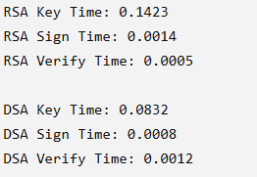

Description
- RSA and DSA key pairs are generated.
- The same message is digitally signed using both algorithms.
- Signature verification confirms message authenticity.
- Execution times are recorded to compare performance.

Advantages
- Compares two popular digital signature algorithms.
- Measures key generation, signing, and verification speed.
- Demonstrates digital signature authentication.
- Useful for selecting suitable algorithms for real-world applications.
- Simple and easy to understand for laboratory implementation.

RUBRICS FOR CALCULATION
